scala> import org.apache.spark.sql.functions._
import org.apache.spark.sql.functions._

scala> val studentsDF = spark.read.option("header","true").option("inferSchema","true").csv("mergeCSV/students_50")
studentsDF: org.apache.spark.sql.DataFrame = [student_id: int, name: string ... 3 more fields]

scala> val coursesDF = spark.read.option("header","true").option("inferSchema","true").csv("mergeCSV/courses_50")
coursesDF: org.apache.spark.sql.DataFrame = [student_id: int, course: string ... 3 more fields]

scala> val mergeDF = studentsDF.join(coursesDF, Seq("student_id"),"inner")
mergeDF: org.apache.spark.sql.DataFrame = [student_id: int, name: string ... 7 more fields]

scala> mergeDF.show()

UseCases :
- The number of students per department
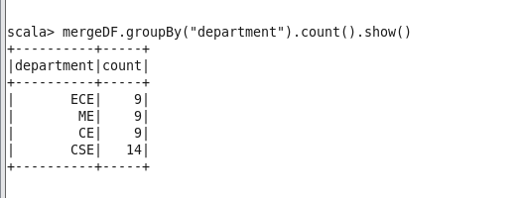
- How to find the average value of marks
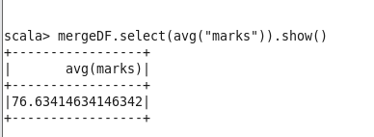
- Top 3 students with the highest marks
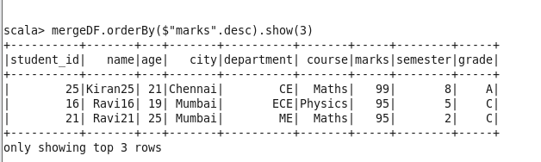
- Number of students who got different grades
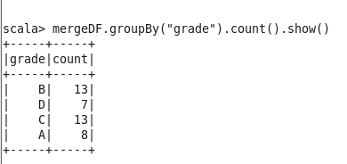
- Students whose name starts with a vowel
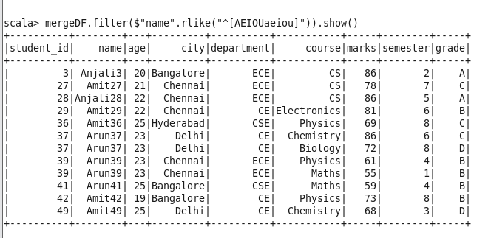
- Find the students from Chennai having marks greater than 80
